Strategy Crib Sheet

Week 1 – Classical Strategy

Lecture Notes
- Strategy is a set of objectives, policies and plans that combine to define the scope of an enterprise and its approach to survival / success
  - As such, it is about knowing where you are and where you want to be
- Profitability is affected by industry effects, firm capabilities and firm positioning
  - Industry effects can be broadly categorised into Porter’s 5 Forces (buyer power, supplier power, barriers to entry, intensity of rivalry, threat of substitutes and price / availability of complements). High competition is likely where market growth is low.
  - Firm-level factors include access to resources, and the ability to exploit these resources. Resources and capabilities combine to form competence, which in turn creates a cost of differentiation advantage, thus value creation
- Generic strategies include differentiation, cost leadership and focus (i.e. differentiation of cost leadership within a particular segment)
  - Differentiation – maximise consumers’ WTP
  - Cost leadership – deliver cheaper than competitors or substitute products, or deliver best value

Reading Notes
- Some managers have failed to distinguish between operational effectiveness and strategy; OE is a necessary but insufficient condition
  - OE is performing similar activities better than rivals
  - Strategy involves performing different activities, or similar activities in different ways
- OE is insufficient because of the rapid diffusion of best practices and the fact that OE’s productivity gains are often captured by suppliers and consumers (thus no change in profitability)
  - Additionally, competitive convergence occurs as rivals outsource activities to third parties, hence these activities become more generic (Porter)
- Competitive strategy rests on unique activities i.e. tailoring activities to the needs of a customer segment to achieve a unique and valuable strategic position
- Origins of strategic positions:
  - Variety-based positioning: specialise a subset of a market’s good or service
  - Needs-based positioning arises where there are groups of customers with different needs. Target a subset based on price sensitivity, feature requirements etc
  - Access-based positioning segments customers who are accessible in different ways, e.g. geography or scale
- Preservable competitive advantage (greater value or same value at lower cost) is the only way to outperform rivals

Week 3 – Blue Ocean Strategy

Lecture Notes
- Blue Ocean strategies challenge assumptions and cross boundaries, which can for example reduce costs whist delivering high value, i.e. breaking the price / value trade-off
  - Airbnb’s lack of fixed costs helped them be both cost leaders and differentiators
  - Apple shifted product-based competition to platform-based competition
  - Can also involve creating a new market, e.g. as Kodak did, utilising the Kodak moment
- However don’t have to venture into distant waters; can pull ideas from existing industries
- Not about tech innovation – the underlying tech already exists. Not about using existing competition as a benchmark; seeks to create leap in value for customers, making competition irrelevant

Developing a Blue Ocean Strategy
- Blue Ocean strategies can be developed by looking across adjacent industries to fuse your offering with theirs, i.e. adding their competitive mix to your own
  - Cirque du Soleil fused the circus industry with the theatre industry
- A strategy canvass shows the different factors upon which an industry competes. Blue Ocean strategies can be developing by creating a strategy canvass and using the “eliminate, reduce, raise and create” framework to change the value curve:
  - For example, Ikea challenge the assumption that customers desire long lasting furniture, and wanted help assembling furniture
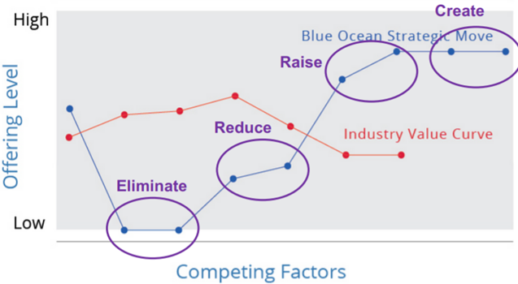
- The value curve show by the strategy canvass can be modified using the 6 Paths Framework, which helps companies move from competing with an industry, to competing across industries. There are 6 categories in which we might alter our scope / offering level:
  - Industry
  - Strategic group
  - Buyer group – who you are selling too, e.g. buyers of Avs have different needs than buyers or normal cars
  - Scope of offering
  - Functional vs emotional orientation of the industry – can incite emotions to stimulate new demand in a functionally orientated industry, e.g. Swatch making watches fun by adding colours. Or the reverse, stripping away extras from an emotionally orientated industry
  - Time – change how your product is consumed across time e.g. Netflix binge-watching, 24h services
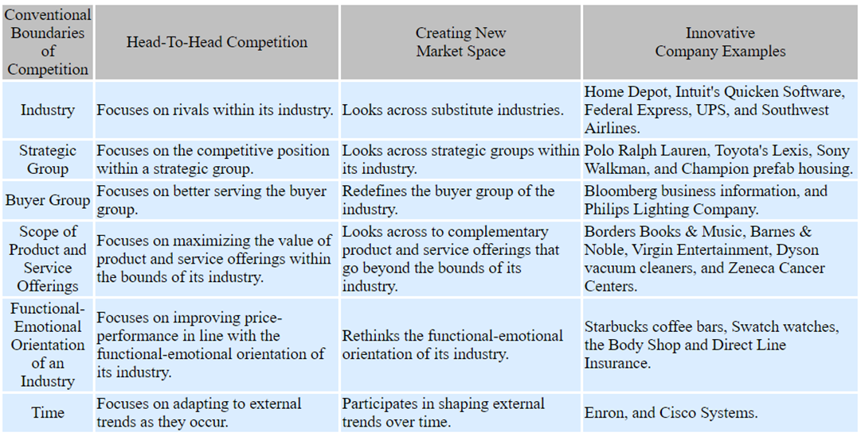

Traits of successful Blue Ocean strategy
- Focus – value curve (strategic profile) should have a clear focus
  - Don’t diffuse effort across too many factors of competition
- Divergence – don’t benchmark against existing competitors, look across alternatives
  - Reactive strategies tend to share similar value curve to competitors
- Compelling tagline – a clear message that advertises the offering truthfully, to win consumers’ trust

Imitation barriers of Blue Ocean strategy
There are factors which make imitation of Blue Ocean strategy difficult. If a company can overcome these barriers where their competitors cannot, they can preserve their strategic position / competitive advantage:
- Cognitive barriers: if value innovation doesn’t make sense to a company’s conventional logic
- Brand barriers: companies who value innovate earn loyal customers who tend to shun imitators, e.g. Apple
  - The strategy may also conflict with the imitator’s brand image
- IP barrier: where initiator patents their innovation, e.g. Dyson
- Economic barrier: network externalities increase difficulty of innovation, e.g. Netflix or similarly where high volumes quickly create a cost advantage, e.g. Swatch

Reading
- About linking existing tech to what buyers value, often contradicting industry wisdom
- Characteristics:
  - Create uncontested market space / create and capture new demand
  - Makes competition irrelevant
  - Breaks the value/cost trade-off
  - Aligns the whole system of a company’s activities

Week 5 – Disruption strategy
- Speed of disruption has increased, with company lifespans reducing and industries collapsing into ecosystems
- Competition has become more asymmetric because firm assets and capabilities are diverging (becoming more specialist)
- Once you lose the war of value, increasing returns to adoption and network effects make growth unlikely
- Key way for incumbents to reduce risk of new entrants succeeding is by being disruptive; this increases chances of growth from 6% to 37%
  - Companies risk becoming too focused on competitors and not customers. This could lead to performance overshoot, i.e. unneeded features which justify higher prices (this links to Blue Ocean strategy)
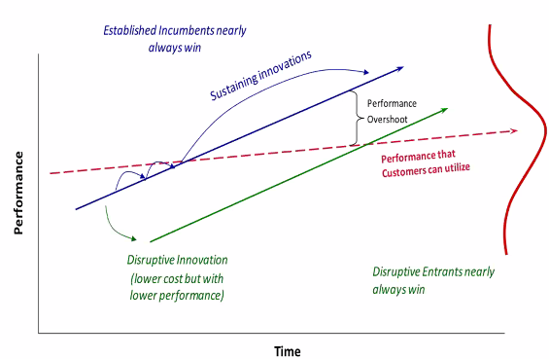
- Incumbents are often saddled with higher costs (e.g. branding, prime real estate highly trained staff)
  - Also difficult for incumbents to scale-down and lean up in response to market changes and disruption. This is because when revenues are falling, these are less profits to fuel investment into a new business model
- Important for business to understand its strategic position; this is your competitive advantage, and anything which attacks this is disruptive. Hence understanding your strategic position helps you spot your disruptors earlier

